Speaking Volumes
Chris Perreault, Editor Summer 2026 Lorie De Marco, President
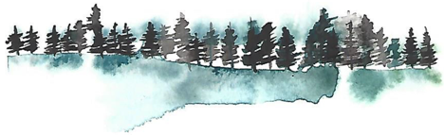
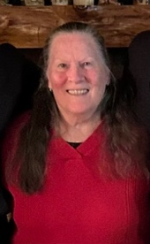

President’s Message
Lori De Marco
After what seemed like a very short (and dry) winter, spring has sprung here on our mountain. We have enjoyed some wonderful weather!
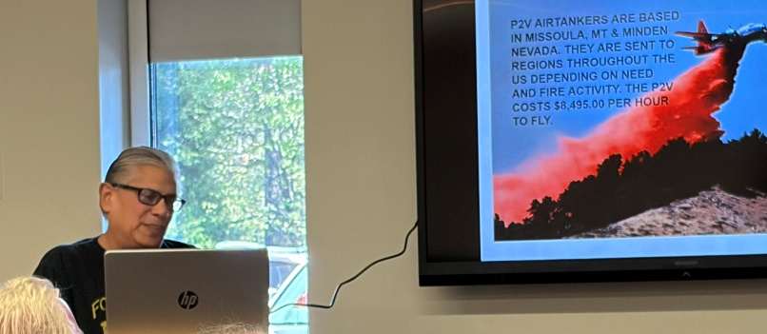
The Friends of the Idyllwild Library have been busy the past few months. Among other things, we have hosted several wonderful programs for you all. I hope you were able to attend one or more of them. Most recently, Idyllwild former firefighter Tom Inocencio presented a fascinating talk, complete with amazing photos, of the devastating fire on our mountain in 2018, showing the valuable air craft fire fighting techniques employed to contain and eliminate the fire. Thank you so much, for this fascinating presentation, Tom!
Tom Inocencio
Other programs included one of our town favorites, Larry Kawano, and his take on the possibility of humans being able to transport to other locations in space – just like in Star Trek. Conclusion? Remote possibility, but extremely unlikely. Sorry, all of you who are hoping to get a quick trip to the moon….
We also enjoyed a talk by local author Bonnie Hardy, who told us all about her series of

mystery books. Interesting topics told with insight and humor, and lots of clues along the way. Another local familiar to most of us, Bob Greenameyer, did a very informative talk on mountain gardening. This man’s areas of expertise never disappoint!
Be sure to stop by the library periodically and check out the ever-changing artist displays in the Community Room, along with the monthly smARTS projects displayed in the main library.

As many of you already know, the Friends of Idyllwild Library is an active group of men and women who have dedicated their time and talents to supporting and serving our wonderful library. One of our fund-raising projects, benefiting our library in many ways, is our very special little Friends Bookstore, located in the library itself. If you haven’t had a chance to check it out, it is very much worth a few minutes of your time. You can purchase hard-back books for as little as $2.00, and paperbacks for $1.00. Many children’s books are available there too. You can also find such things as mugs, travel mugs, magnets, tote bags and more. A recent addition to items available is an assortment of jigsaw puzzles. We’re looking at some very exciting additions to the gift portion of the bookstore, so
Do you have children’s books that your kids have grown tired of, outgrown, or just don’t need any more? Please consider donating them to the library to be sold at the bookstore. We also maintain and stock TWO Little Free Libraries – one at the Town Hall and one at the Nature Center. Your donations
are greatly appreciated!



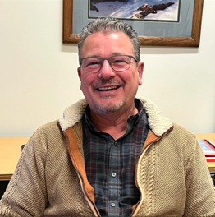
Message from James,
Library Manager
It’s been a fantastic few months at the Idyllwild Library! We’ve welcomed a wonderful mix of locals, weekenders, and out-of-town visitors, and we’ve truly had something for everyone. From entertaining talks by the likes of Bob Greenamyer and Larry Kawano, to a hands-on Cyanotype workshop with Mallory Cremin, it’s been a busy season. We’ve also showcased incredible local artists, hosted lively book clubs, a knitting club, adult crafts, trivia nights, and so much more.
I want to express my deepest gratitude to all the patrons who visit the Idyllwild Library, as well as the Friends of the Idyllwild Library, our staff, and our volunteers who make it all possible. Through their dedicated service, the Friends help us discover and fund the very programs we love to put on for the Idyllwild community. There is nothing I enjoy more than seeing a Community Room full of folks enjoying these events!
I also want to recognize our incredible team:
- Claire, our new(ish) librarian, who has been putting together entertaining programs that promote Early Childhood Development, alongside our new Trivia Nights and Adult Art/Craft programs.
- Yumi, the dynamic center of our library, who keeps everything on track and promotes our branch through her wonderful creativity.
- Miles and Maygen, who provide exceptional customer service, welcoming everyone and making sure all our programs run smoothly and successfully.
- Our Volunteers, who keep the library beautifully organized and make the Friends’ Bookstore an amazing resource for all who visit.

Looking Ahead: Summer 2026
We are thrilled for our upcoming Summer programs! Running from June 9th through July 17th, we will host our annual Summer Reading Adventure (SRA), which is open to all ages. This program is designed to keep readers engaged during the summer months—a vital skill for developing concentration and lifelong learning.
We will also host Lunch at the Library on Wednesdays and Thursdays, providing picnic-style lunches for kids up to 18 years old. During these weeks, we’ll have entertainers, Art & STEAM programs, and lots of prizes (a huge thank you to the Friends of the Library and the community partners who donated them!). It is going to be a blast, and we are hoping for a record turnout this year.
Additionally, keep an eye out for the Friends-designed and sponsored Author Faire, where we will host a number of local authors sharing their stories and craft with locals and visitors alike!
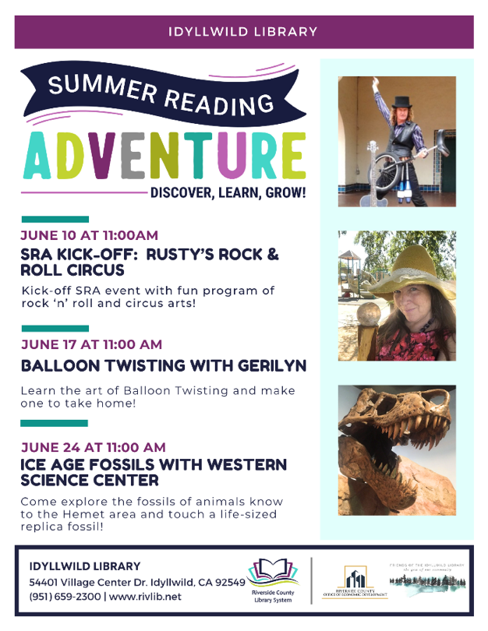
There is no better place to recharge than nestled among the stacks at the Idyllwild Library.

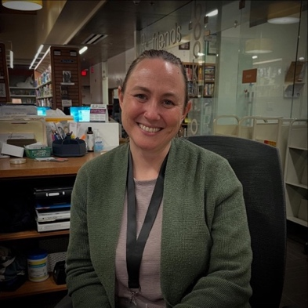
Meet
Claire Burke

Meet Claire Burke, our “newest” library staff member. Claire is replacing Susan Righetti so she has some big shoes to fill. The best thing I can tell you about Claire is, she is HAPPY- HAPPY- HAPPY! Claire was raised in Riverside, CA with her only brother who is autistic. She worked at the Riverside County Library and fell in love with libraries. She attended Humboldt State University where she majored in Theater. She can be a ham…come watch her during Story Time. She met her husband, Ryan at Humboldt and after getting to know Claire’s brother, he decided to go into special Education. Claire also came out of college and worked for a company that assisted special needs individuals. She has lived in Temecula until recently when she and her husband moved to Garner Valley. She loves reading (of course), concerts, Halloween & Trivia. Claire has instigated a “Trivia Night” at the library. She has a Masters of Library Science and fulfills many roles at our small town library. If you don’t know Claire yet, stop in and say hi; she’s amazing!

Coming June 17th
Gallery Opening - By Trine Bietz
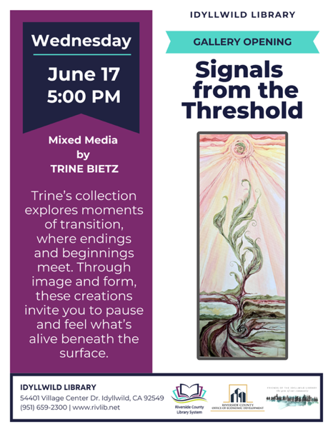

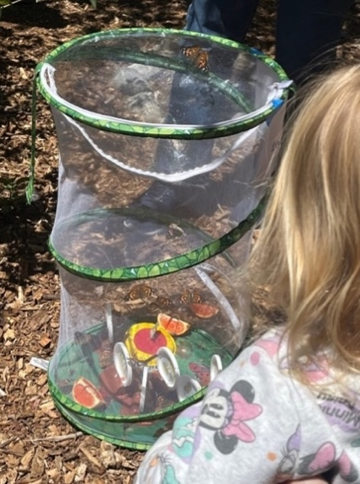
Children’s Programs
Claire Burke
Last week was the much anticipated release day for our Painted Lady butterflies at the Idyllwild Public Library! Beginning their lives as pint-sized, spiky caterpillars, patrons at the library were able to see them grow into their “chonky” phases, then morph into chrysalises, and finally into the beautiful butterflies that were released today. Kids learned about their pivotal life stages along with some fun trivia (they taste with their feet and the only place they don’t inhabit is Antarctica)! As my first time running this program, it was fun to see the kids come to the library and hear them talk about the changes they observed and the excitement for release day! Much appreciation goes to the FOL for supplying the materials needed for this fun and engaging children’s program!
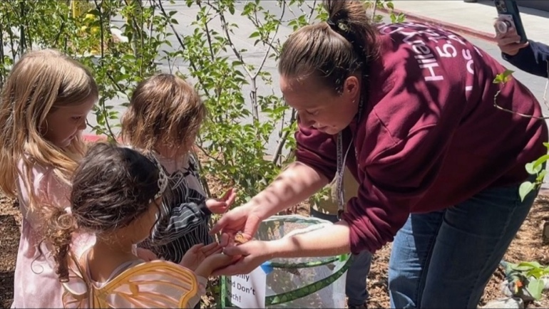

Upcoming Kids Events

With Summer Reading Adventure just on the horizon, this is what’s coming up for the Children’s Program:
- Rusty’s Rock and Roll Circus (6/10)
- Balloon Twisting Storytime with GeriLyn (6/17)
- Ice Age Fossils with the Western Science Center (6/24)
- Storytime with the Nature Center (7/1)
- Sandii Castleberry “Singing Your Way to Reading” (7/8)
- Storytime with Author James Da Silva: The Great Adventures of Littlefeet (7/15)
- SRA Awards and Christopher T. Magician (7/22)
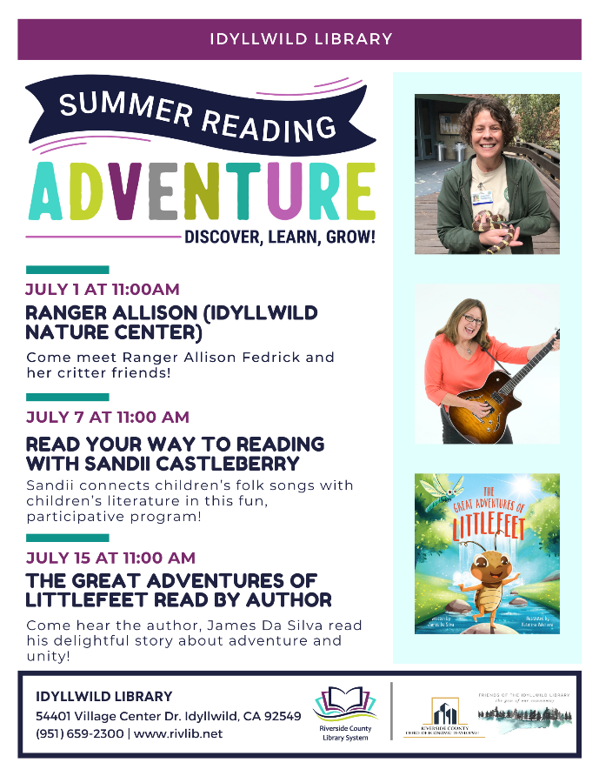

Don’t Forget…
Story Time Wednesdays: 11:00 a.m.

Membership Renewal

Please use the QR code below to go directly to our membership renewal page where you can use PayPal or a Credit Card to renew your membership. Thank you.

Family Movie Night
Fridays 2:00 – 4:00

Dumbo (6/12)
Up (6/19)
Ice Age (6/26)
National Treasure(7/3)
Sing (7/10)

Upcoming Events




Friends of the Library
P. O. Box 2183
Idyllwild CA 92549

□ Individual $15.00
□ Family $25.00
□ Business or Organization $50.00
□ Sapphire $100.00
□ Ruby $250.00

□ Emerald $500.00
□ Diamond $1000.00
Name
Address
City/State/Zip Date ________________
Telephone e-mail address
□ New □ Renewal □ Gift from
The Friends of the Idyllwild Library is a 501(c)3 organization.
Contributions are tax deductible as allowed by law.
Please send your tax-deductible check to:
Friends of the Idyllwild Library, Attn: Jeri John, PO Box 2183, Idyllwild CA 92549-2183

ASK A FRIEND TO JOIN THE FRIENDS OF THE IDYLLWILD LIBRARY

