Speaking Volumes
Chris Perreault, Editor January 2026 Lorie De Marco, President
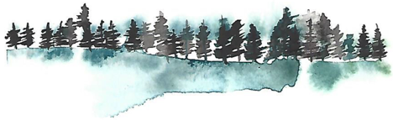

President’s message
“At the Peak”

------------------------------------
Welcome to 2026! This year just flew by, leaving us in an abundance of wet weather. Holiday plans interrupted, travel made more challenging, but we made it! I hope you all had a wonderful season of friends, family, great food, and fun.
The Friends of the Idyllwild Library finished our year with our annual election of Board Officers at a short meeting just before our beloved women’s choral group, Local Color, performed at the library. As always, it was a nice evening with beautifully sung carols…. just what we needed to get us in the mood for the coming holidays.
We held our election, and the following people were elected unanimously:
President, Lorie De Marco
Vice President, Chris Perreault
Treasurer, Steve Perreault
Recording Secretary, Molly Coyner Cozens
Corresponding Secretary, Susan Judkins

We are ready for the new year, supporting and assisting our wonderful library staff, arranging and sponsoring programs, helping to fund new books for the library collections, providing support for the Children’s Programs, maintaining and stocking two Little Free Libraries (one at Town Hall, and one at the Nature Center), and staffing and operating our Friends Bookstore (if you haven’t taken advantage of the amazing low prices in our little bookstore, be sure to give it a try). I do want to mention that our bookstore is staffed totally by wonderful volunteers, and we sincerely thank them!
This year we said goodbye to several of our board members, leaving a couple of vacancies. If you are interested in joining our group, contact me via e-mail at loriedemarco21@gmail.com. One position we’re seeking to fill is a manager for our bookstore. We have several very qualified and dedicated volunteers who take care of the day-to-day responsibilities, and one who manages the merchandise and displays. We would like to have someone who can serve as the “hub” to coordinate the operation. Is that you?
I’m sure you are all aware that the library hosts at least one community program each month, and the Friends of the Library plan one per month as well. We have had a variety of programs, ranging from author talks to bird watching, from Native American programs to outer space. I hope you all take advantage of these enriching programs in the coming year; we’d love to see you there. We’re always looking for interesting topics, and welcome suggestions from our supporters. If you have a special skill or talent you would like to share, or if you know someone who does, just let us know.
The more that you read,
the more things you will know.
The more that you learn,
the more places you’ll go!” Dr. Seuss
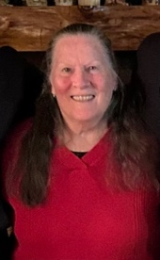

Lorie De Marco
President, Friends of the Idyllwild Library

Message from James,
Library Manager

Rooted in Community: A Season of Change at the Idyllwild Library
Nestled among the pines and cedars, the Idyllwild Library has always been more than just a place to borrow books. It is the heartbeat of our mountain village—a sanctuary for curious minds, a hub for local creators, and a warm gathering space for neighbors. As we look back on the past year, our impact on the community has reached new heights, driven by both a shared passion for learning and the invaluable support of our partners.

Honoring Our Legends
The year 2025 marked a significant milestone for our branch as we bid a bittersweet farewell to two true Idyllwild Library Legends: Susan Righetti and Colleen Tell. For years, Susan and Colleen were among the friendly faces that defined the library experience for so many of us. From Susan’s passion for children’s programing to Colleen’s tireless dedication to patron service and deep knowledge of our collections, their impact is woven into the very fabric of this building. They didn't just check out books; they built relationships and served as the steady stewards of our community’s stories. While we miss their daily presence, we are infinitely grateful for the legacy of kindness and excellence they left behind.

New Faces and New Opportunities
As we honor the past, we are also excited to embrace the future. We are thrilled to welcome our new librarian, Claire Burke, to the Hill! Claire joins us with a fresh vision and a passion for community engagement. If you haven’t had the chance yet, please stop by the desk to introduce yourself and give her a warm Idyllwild welcome.

The Power of Partnership
None of our achievements—from our always successful Summer Reading Program to our vibrant local history and art displays—would be possible without the Idyllwild Friends of the Library (FOL).
This dedicated group of volunteers is the love and support behind so much of what we do. Through their tireless efforts with book sales and fundraisers, the FOL provides the critical funding that allows us to go above and beyond. It is because of the FOL that we can offer:
- Guest Speakers: Bringing experts in ecology and art directly to our mountain.
- Enhanced Collections: Keeping our shelves stocked with the latest bestsellers.
- Community Events: Funding materials for seasonal festivals and children’s activities.
The partnership between the library staff and the FOL is a beautiful example of community synergy. While the library provides the space, the FOL provides the "soul" and the extra resources that turn a good library into a great one.

Looking Ahead
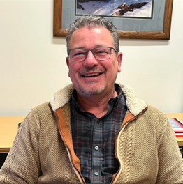
The Idyllwild Library reflects the people who walk through its doors. Whether you come to escape into a novel, research local heritage, or attend one of our many programs, you are part of our story. We are deeply grateful to every donor, volunteer, and reader who makes this institution a cornerstone of mountain life.
James Wyatt,
Library Manager

Upcoming Programs
Devona Maillard
Don’t you just love our Idyllwild traditions? Shared experiences provide a deep sense of community. The Friends of the Library sponsored Local Color’s performance on December 10th is just such an event. The Tree Lighting, the Winter Master Chorale, and the Local Color performance allow for a brief pause in the holiday chaos; a deep breath. Ahhh. Now it seems like Christmas.

The Local Color performance put an exclamation point on a great year of Friends’ Programs during 2025, but not to rest on our proverbial laurels, 2026 is here and we have some fun, interesting, and even exciting programs in the works. On February 10, Larry Kawano will present his talk on “Beam Me Up Scotty”, or things related to time travel and some such. Larry explains complex scientific concepts in accessible layman’s terms. His talks are always interesting, educational and fun.

Throughout the rest of the year, we will be learning about gardening in Idyllwild, Idyllwild’s movie history, the history of Idyllwild Arts, and all about Spirit Mountain, with likely more to come. We look forward to seeing you at our Tuesday Evening Programs. Look for the program announcements on Facebook, Good Morning Idyllwild, and the Library flyers.

Children’s Programs
Luanne Galizio
The Children’s Library is running strong, despite the loss of our dear Susan. Colleen, Yumi, and James (as well as volunteers) have really stepped up! On Wednesday mornings at 11:00, story time continues. Colleen has recruited new readers, and, despite her trepidation, has quite successfully led a few herself! We have seen a surge of new, younger children, many second generation from the same family; once babies on Mom’s lap, to toddlers on the carpet. The children have been bringing toys, often theme related. Sharing theme related toys with the group is fun, but otherwise the toys need to be given to parents at the start of the hour, as they have become a distraction. The highlight of this year was a visit from Mrs. Claus, who regaled the children with fun magic tricks, stories, and face painting. Wrapped book gifts were handed out, and Christmas cookies were decorated.
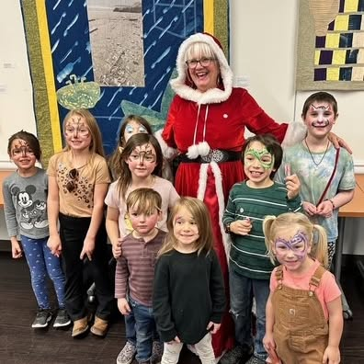
A new addition has been a collaboration with the SmArts program - a brainchild of James and Luanne, the Children’s program Coordinator and a SmArts Artist/Instructor. Approximately every two weeks we have a new display (above the self check out) of a class’s artwork from Idyllwild Elementary. It has been featured in the Town Crier every time the display changes. This has brought in more children, and community members, to see their artwork. James reports that those that come in often stay awhile and check out books or peruse the bookstore.

Don’t Forget…
Story Time Wednesdays: 11:00 a.m.

Friends of the Library Social Media
Please visit us on social media! The Friends of the Idyllwild Library now have accounts on Facebook, and Instagram.
For more information on upcoming programs, check our branch calendar at www.rivlib.net or the Friends’ webpage at http://www.friendsofidyllwildlibrary.com

Membership

Please give your support to our library by renewing your membership. This link www.friendsofidyllwildlibrary.com allows you to click on membership. Or pick up a membership envelope in the Friends Shop in the library and mail it in. You can also use the QR Code to renew online. Thank you to all who have renewed their annual membership.

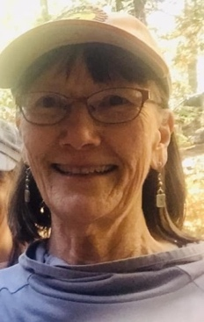
Thank you, Jeri John -
Membership Chair


Friends of the Library
P. O. Box 2183
Idyllwild CA 92549

February is renewal time! To help keep our costs down, we would love if you would renew your Friends Membership online.
Please use the QR code below to go directly to our membership renewal page where you can use PayPal or a Credit Card to renew your membership. Thank you.


□ Individual $15.00
□ Family $25.00
□ Business or Organization $50.00
□ Sapphire $100.00
□ Ruby $250.00

□ Emerald $500.00
□ Diamond $1000.00
Name
Address
City/State/Zip Date ________________
Telephone e-mail address
□ New □ Renewal □ Gift from
The Friends of the Idyllwild Library is a 501(c)3 organization.
Contributions are tax deductible as allowed by law.
Please send your tax-deductible check to:
Friends of the Idyllwild Library, Attn: Jeri John, PO Box 2183, Idyllwild CA 92549-2183

ASK A FRIEND TO JOIN THE FRIENDS OF THE IDYLLWILD LIBRAR

